DSP Homework 12

Did not do Problem 1 c or d

Problem 2c)

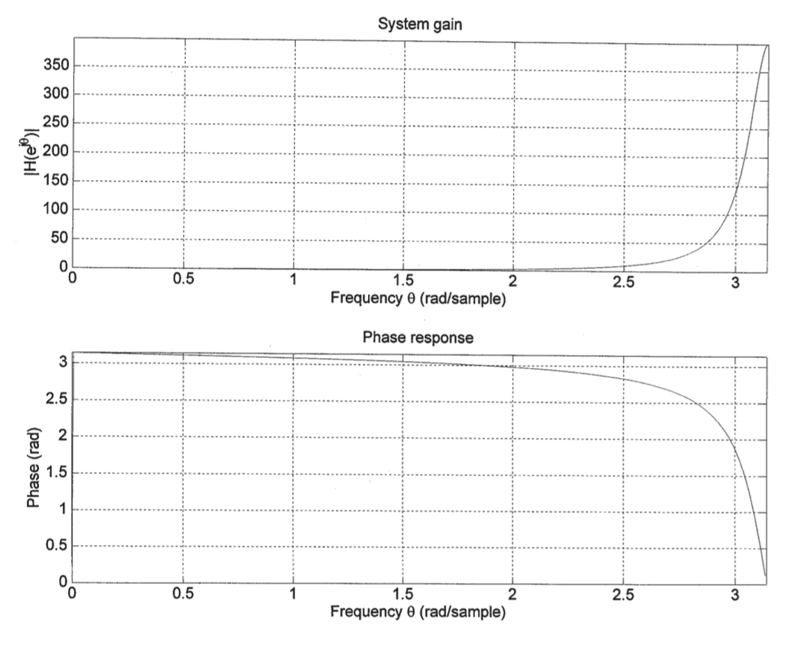

Problem 3c)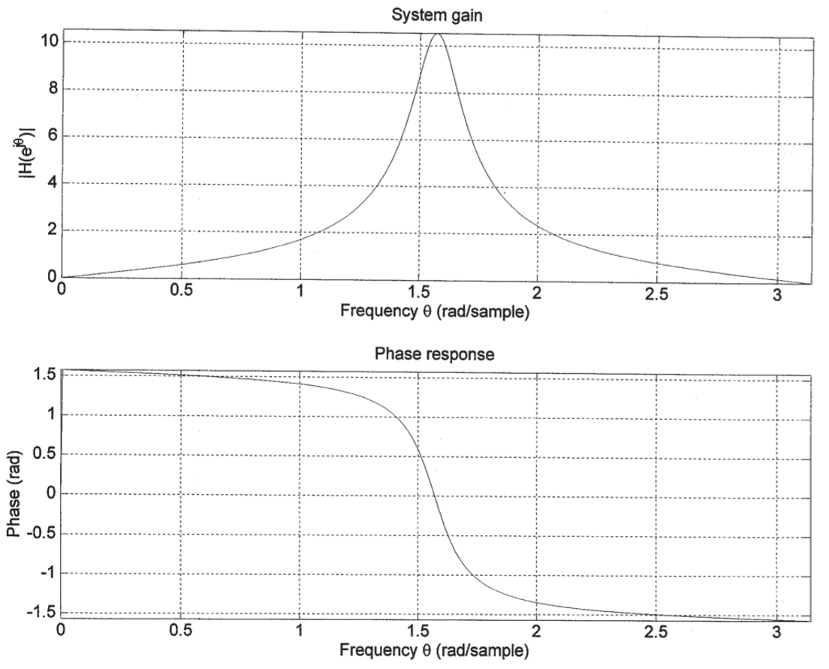

Problem 4c)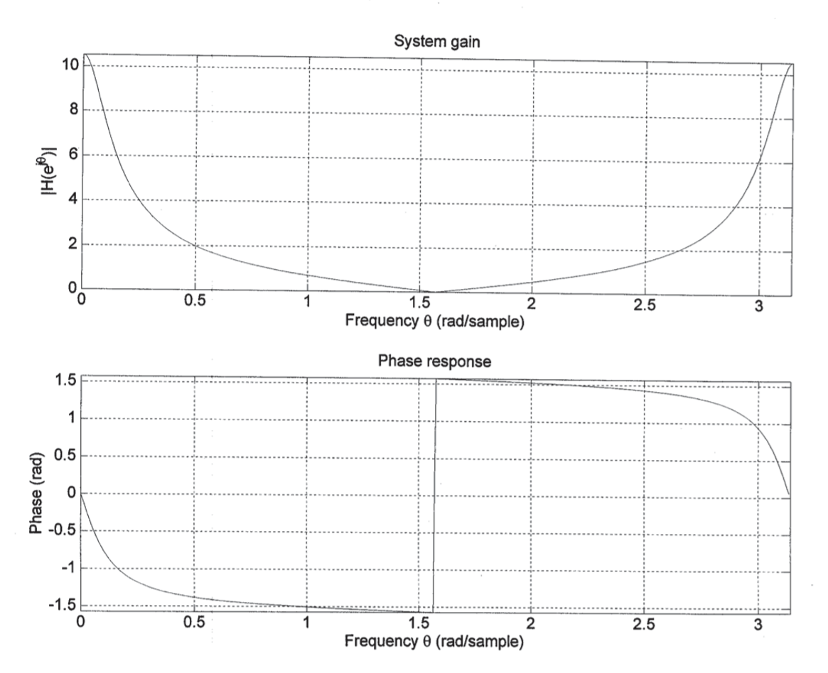

Did not do problem 5